**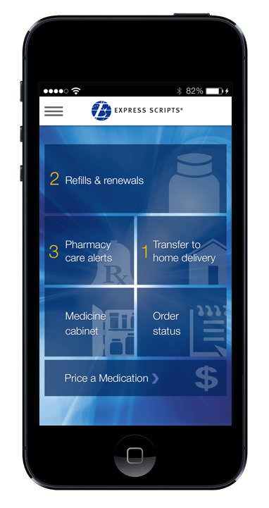The Express Scripts Mobile App**

**Get the app that drives better decisions**

**and healthier outcomes for members *on the go.***

The **Express Scripts mobile app** helps you stay on track with instant access to your personal medication information – anytime, anywhere. Click [here](https://host1.medcohealth.com/consumer/site/home?partner=MOBI&accessLink=Newsletter&utm_source=newsletter&utm_medium=QRcode&utm_campaign=Newsletter) to learn more. Using your mobile device, click [here](http://qrs.ly/xi3swts) or scan the QR code to download the app now for free!

After downloading the app, log in with your Express-Scripts.com username and password. If you haven’t yet registered with Express-Scripts.com, you can create a username and password right from the app – and use the same username and password to access our website, Express-Scripts.com, and our mobile website, m.express-scripts.com.

From the mobile app, you’ll have instant access to these great features:

|  |  |
| --- | --- |
| C:\Tara's Files\eCommerce Communications\Mobile Apps & Texts\Images\Icons\Refills and Renewals.png | **Refills and Renewals**†Running low? One touch and you’re good to go. Get home delivery refills right to your door – right here! |
| C:\Tara's Files\eCommerce Communications\Mobile Apps & Texts\Images\Icons\Order Status.png | **Order Status**† On its way? Just swipe the screen with your finger to track your home delivery prescription order status. |
| C:\Tara's Files\eCommerce Communications\Mobile Apps & Texts\Images\Icons\Medicine Cabinet.png | **Medicine Cabinet** Check interactions, set reminders, manage medications and update your history – all in one spot. |
| ttm_mobile.png | **Transfer to Home Delivery**†  Save the runaround (and maybe some money) on prescriptions you take on an ongoing basis. |
|  | **Price a Medication**  Compare drug prices for home delivery and multiple local retail pharmacies. |
| C:\Tara's Files\eCommerce Communications\Mobile Apps & Texts\Images\Icons\My Rx Choices.png | **My Rx Choices**®† View lower-cost options available under your plan and discuss them while you’re still in the doctor’s office! |
| C:\Tara's Files\eCommerce Communications\Mobile Apps & Texts\Images\Icons\Pharmacy Care Alerts.png | **Pharmacy Care Alerts**†Get personalized alerts to help make sure you’re following your doctor’s prescribed treatment plan. |
| C:\DESKTOP TEMP\icon_claims_history.png | **Claims and History** View your past prescription activity and payment details. |
| locate_mobile.png | **Locate a Pharmacy**† Search for the nearest in-network preferred retail pharmacies, view contact information and access directions. |
| C:\Tara's Files\eCommerce Communications\Mobile Apps & Texts\Images\Icons\ID Card.png | **Virtual Member ID Card**†Forgot your wallet? No problem. If you’ve got your device, you’ve got your ID. |
| druginfo_mobile.png | **Drug Information**  Search detailed drug information and see potential side effects, drug interactions, pill images and more. |

**Download the Express Scripts Mobile App today for free!**

\* The Express Scripts mobile app is available to members using the following mobile devices:

Apple – iPhone® 4, 5 and 6 series, iPad®; Android™ – OS 4.0 & later; Windows Phone®;

BlackBerry® – All devices running OS 10.3 and later; Amazon- All devices except the Kindle Fire 1st generation

† Available if these features are turned on for your group on Express-Scripts.com